EXERCISE 10.1

Question 1:

How many tangents can a circle have?

Solution: There can be infinitely many tangents to a circle.

Question 2:

Fill in the blanks:  
(i) A tangent to a circle intersects it in ………… point(s).  
(ii) A line intersecting a circle in two points is called a ………… .  
(iii) A circle can have ………………. parallel tangents at the most.  
(iv) The common point of a tangent to a circle and the circle is called ……….. .

Solution:

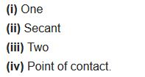

Question 3:

A tangent PQ at a point P of a circle of radius 5 cm meets a line through the centre O at a point Q so that OQ = 12 cm. Length PQ is  
(a) 12 cm  
(b) 13 cm  
(c) 8.5 cm  
(d) √119 cm

Solution:

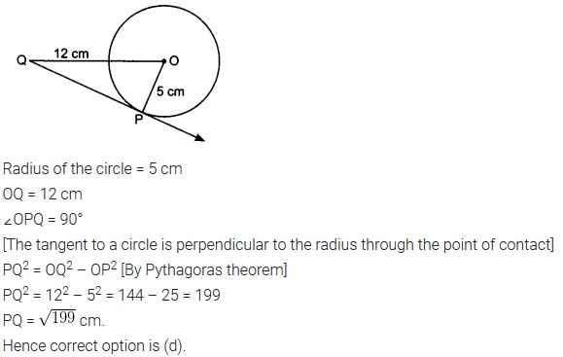

Question 4:

Draw a circle and two lines parallel to a given line such that one is a tangent and the other, a secant to the circle.

Solution:

